Functional & Performance Testing Template
Model Performance Test

Date | 30 September 2026
Team ID | SWTID-2026-8886
Project Name | Implement Client Script and UI Policy for Incident
Maximum Marks

Test Scenarios & Results
Test Case ID | Scenario (What to test) | Test Steps (How to test) | Expected Result | Actual Result | Pass/Fail
FT-01 | High impact policy | Open Impact=1 Incident | Group and assignee required; Urgency read-only | Not run | Not run
FT-02 | Urgency onChange | Change Impact to 1 | Urgency set to 1 once | Not run | Not run
FT-03 | Save validation | Leave each routing field empty in turn | Save blocked with matching field message | Not run | Not run
FT-04 | Reverse condition | Change Impact to 2 | Policy effects reverse | Not run | Not run
FT-05 | List State edit | Use list editor on State | Edit declined | Not run | Not run
FT-06 | Form State update | Change State from form | Normal server rules apply | Not run | Not run
PT-01 | Client response | Change Impact repeatedly in test instance | No external call; record observed latency | Not run | Not run
PT-02 | API speed | No external API in project | Not applicable | Not run | Not run

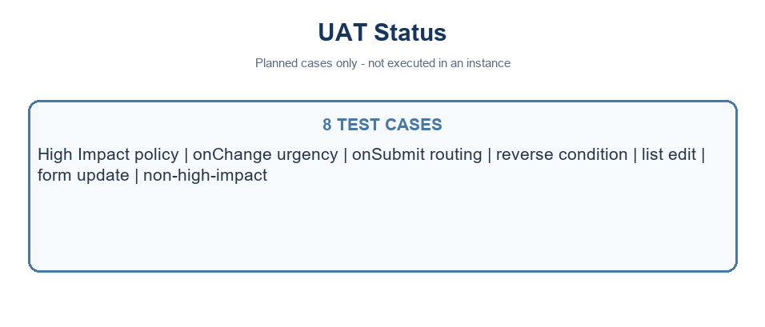
Planned UAT coverage - no results recorded
Project note: values use the standard Incident choices where Impact 1 and Urgency 1 represent High. Confirm field names and values in the target instance.

